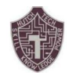 Hutch Tech JROTC September Newsletter 2022
By: Cadet Staff Sergeant Ismriti Magar
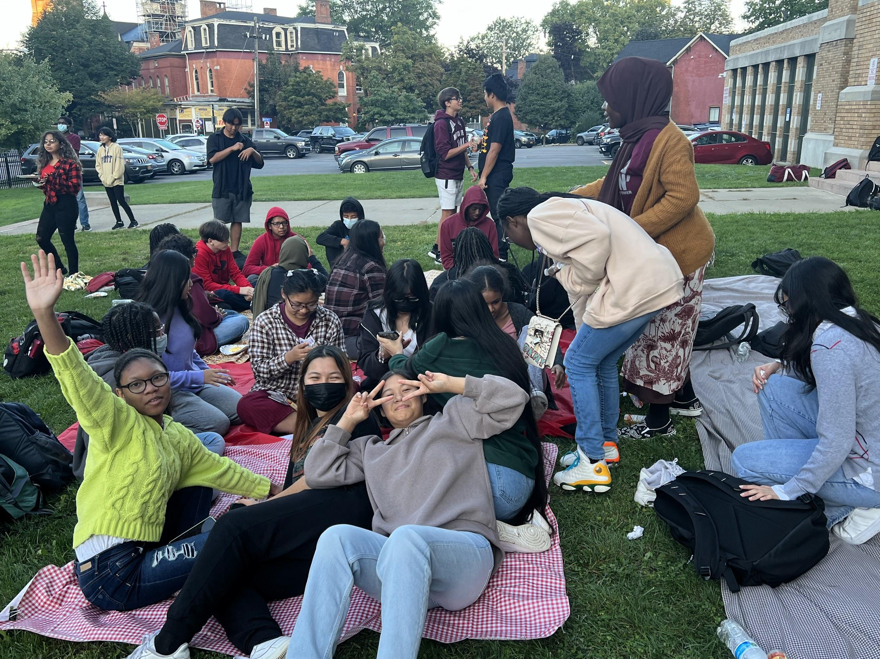
CADET BREAKFAST
Freshman cadets were given the opportunity
to grow stronger connections with their
classmates. The breakfast was held outside
in the morning. There was food(breakfast),
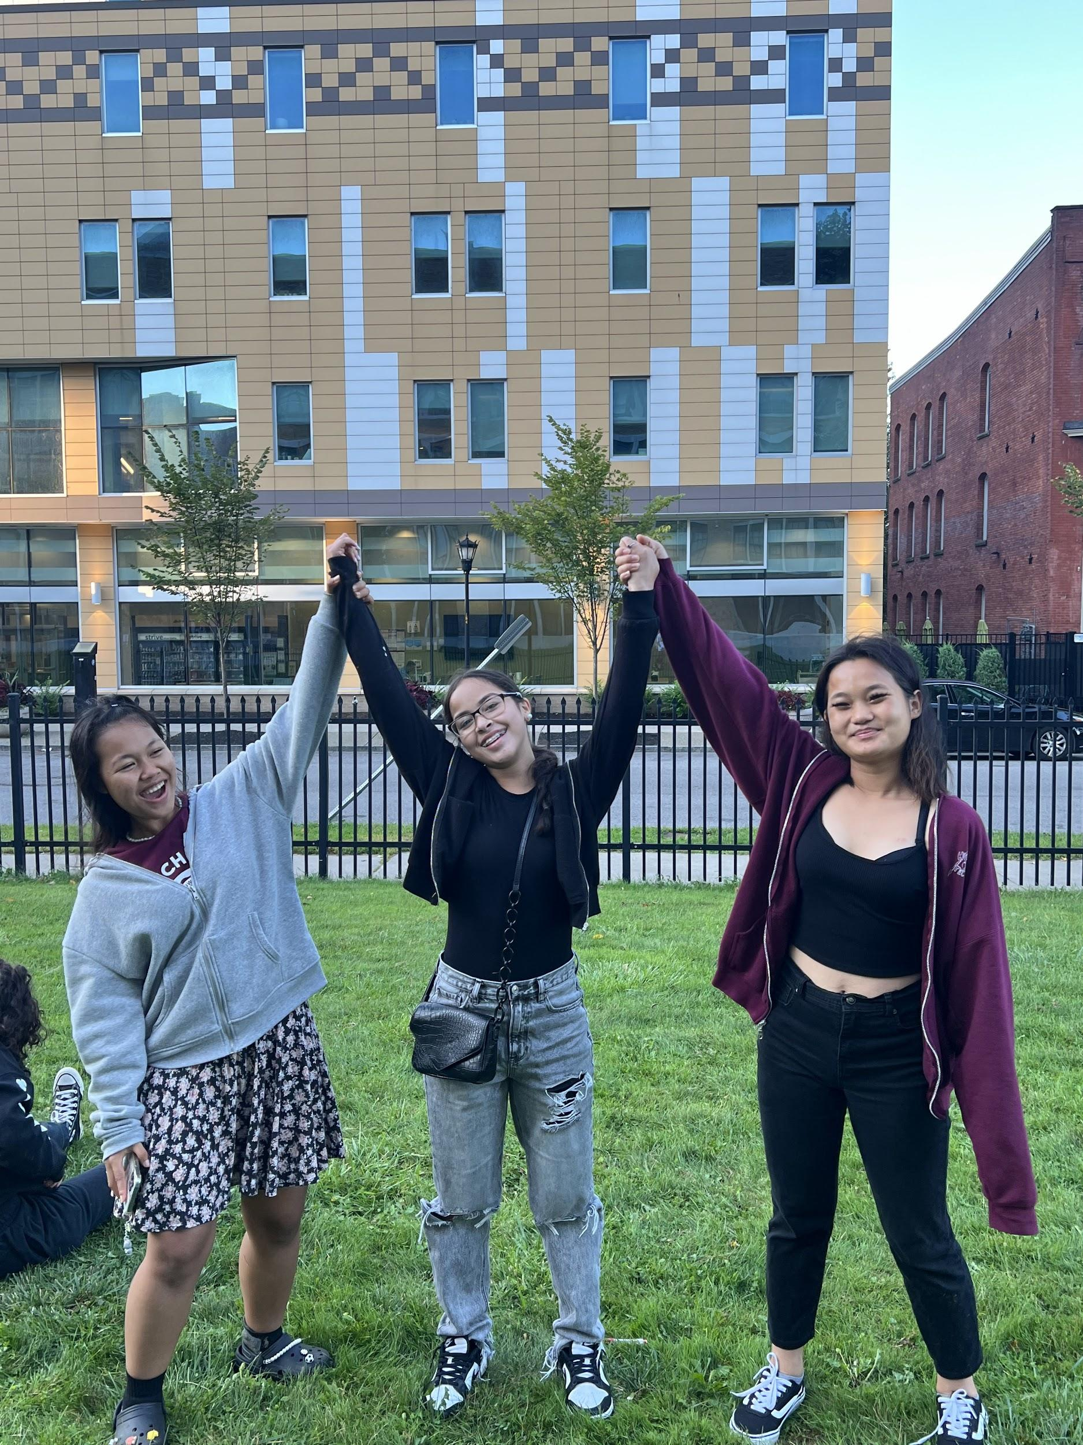
drinks, games, and team building activities.
The cadets were introduced to their
company commanders, platoon leaders,
and upperclassmen. Overall this was a successful
event that resulted in many happy faces.

DONATE/CONNECT LIFE
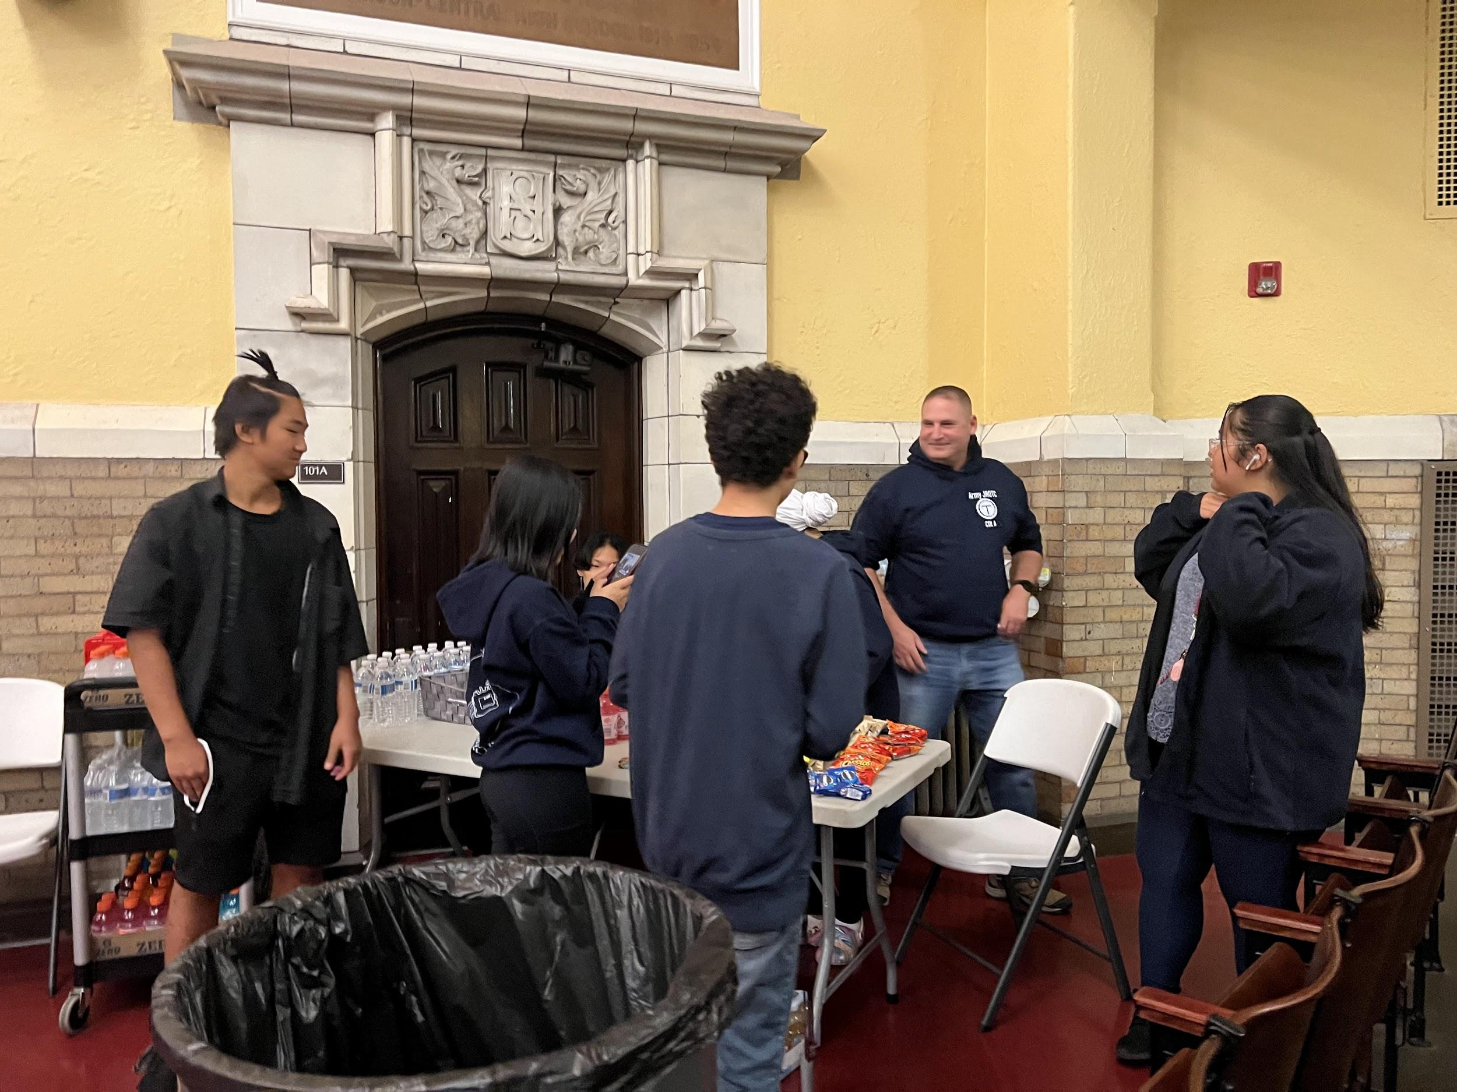
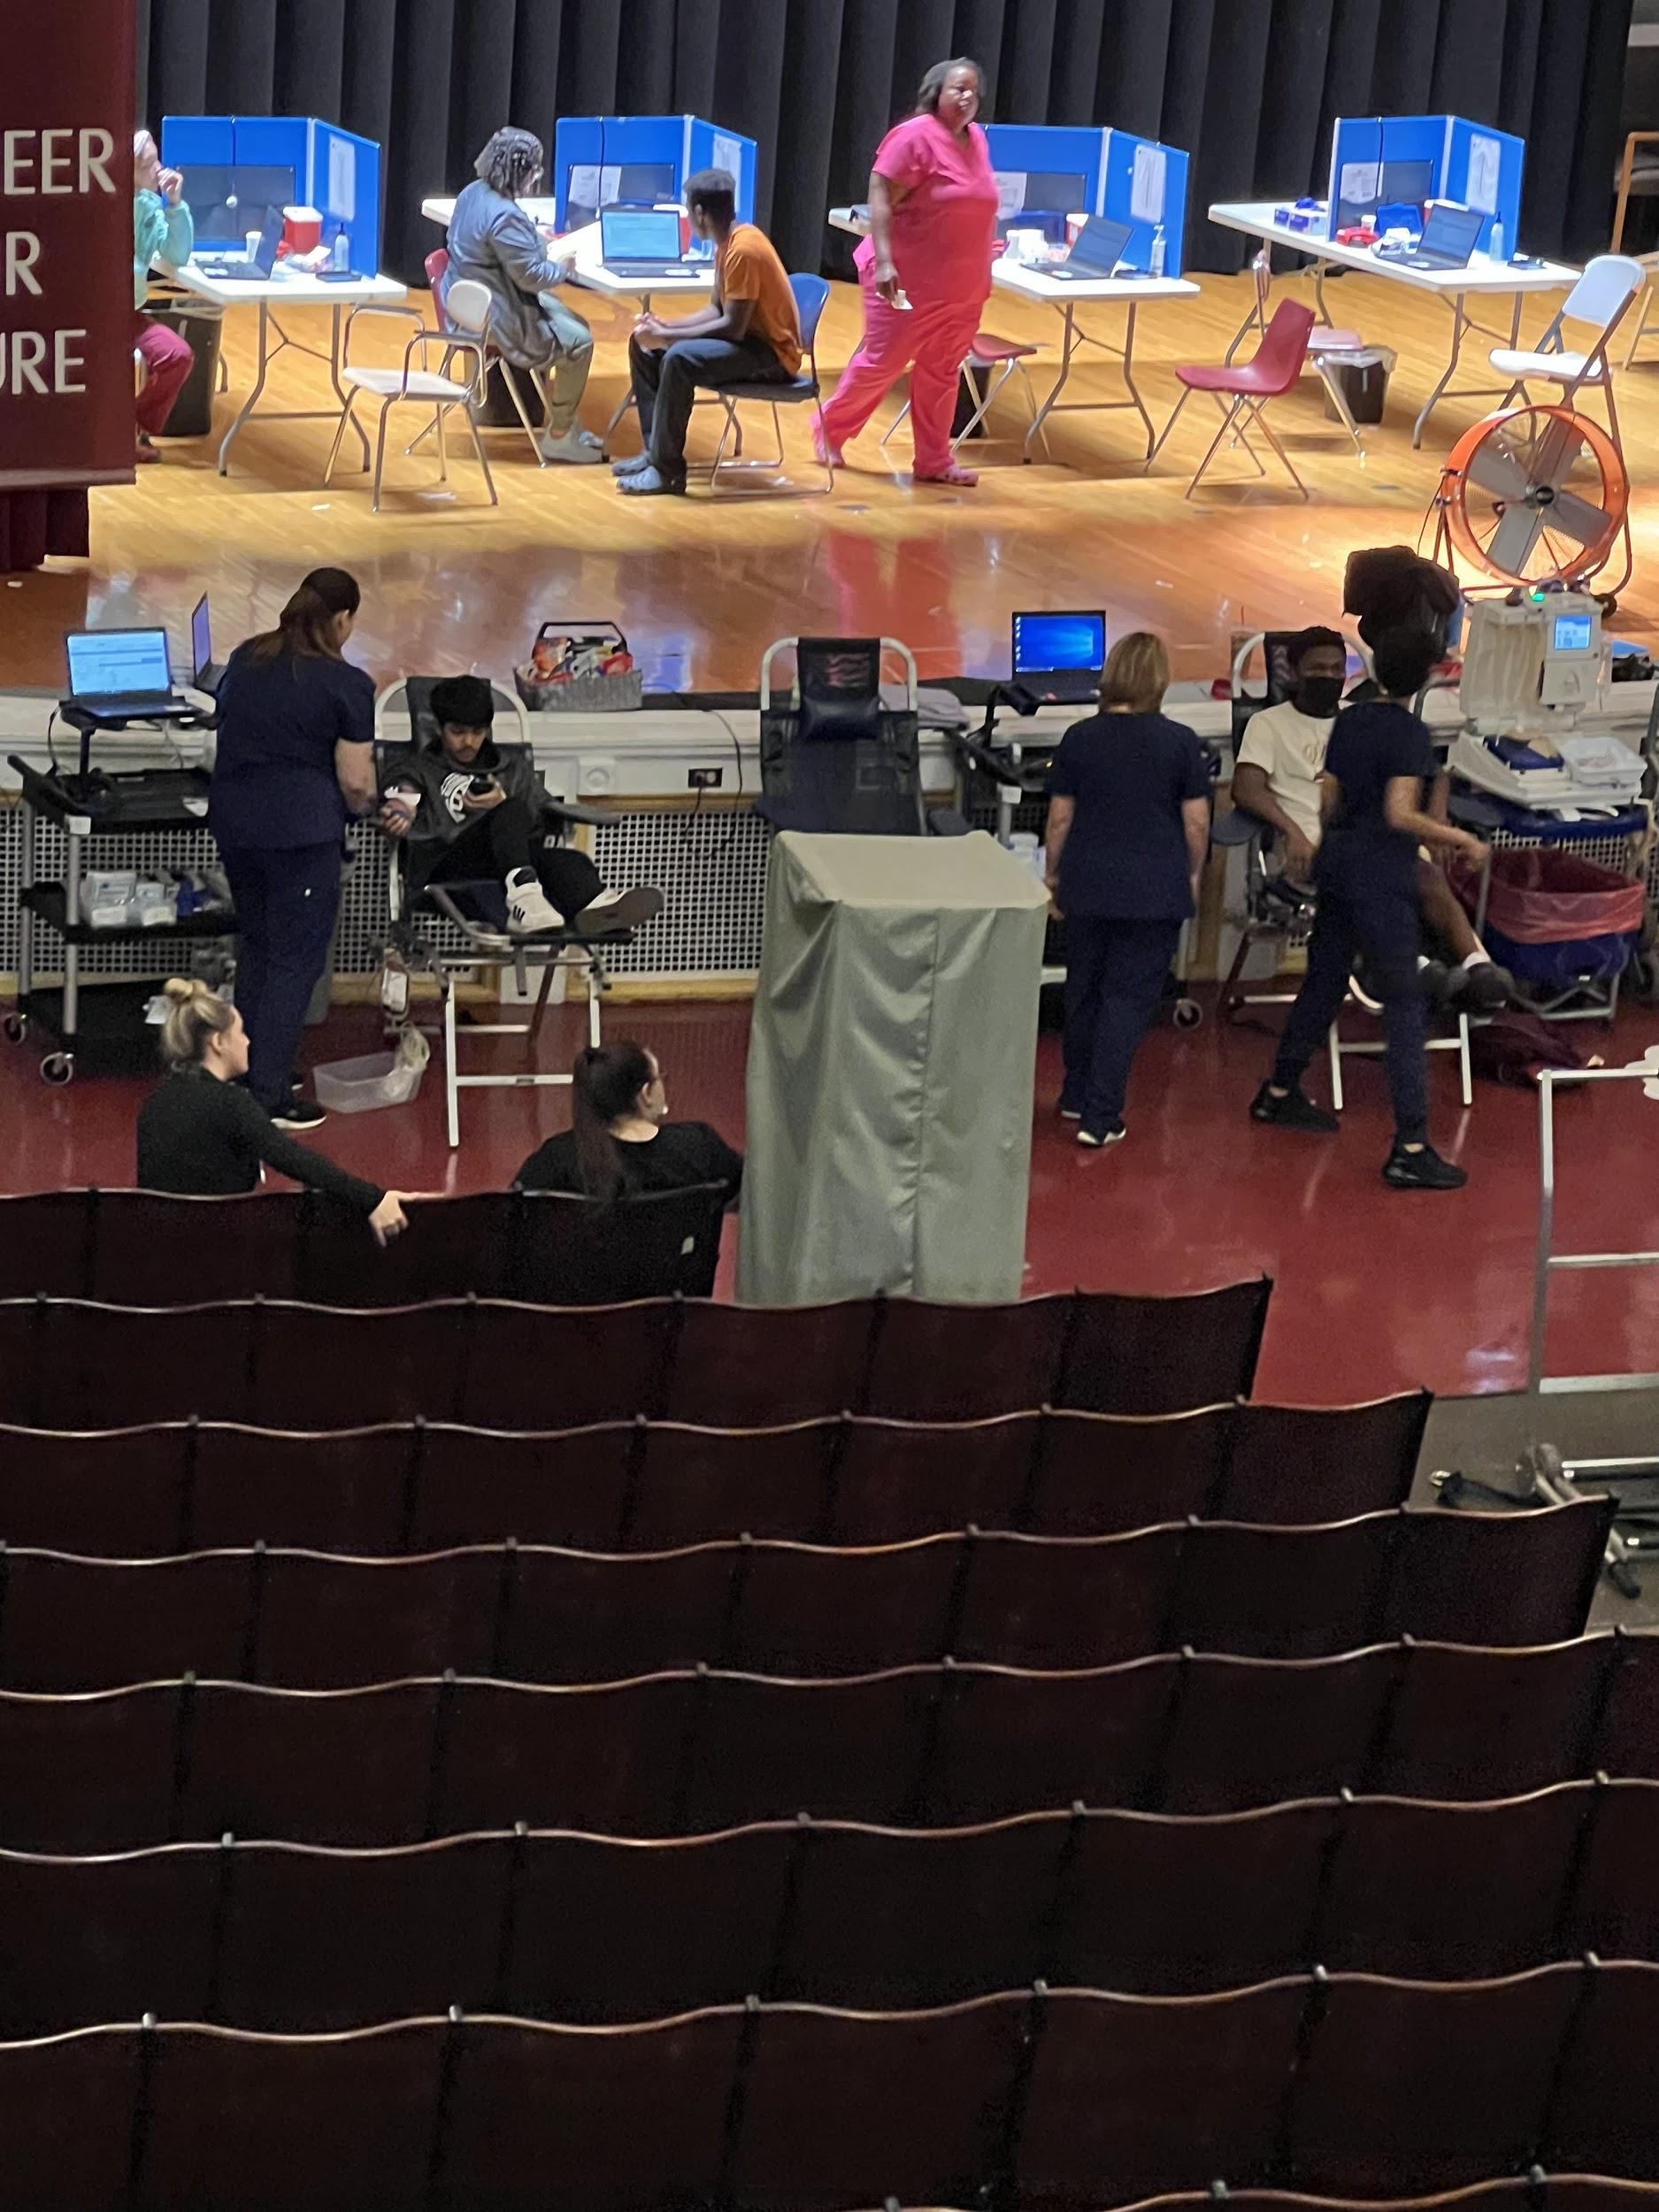
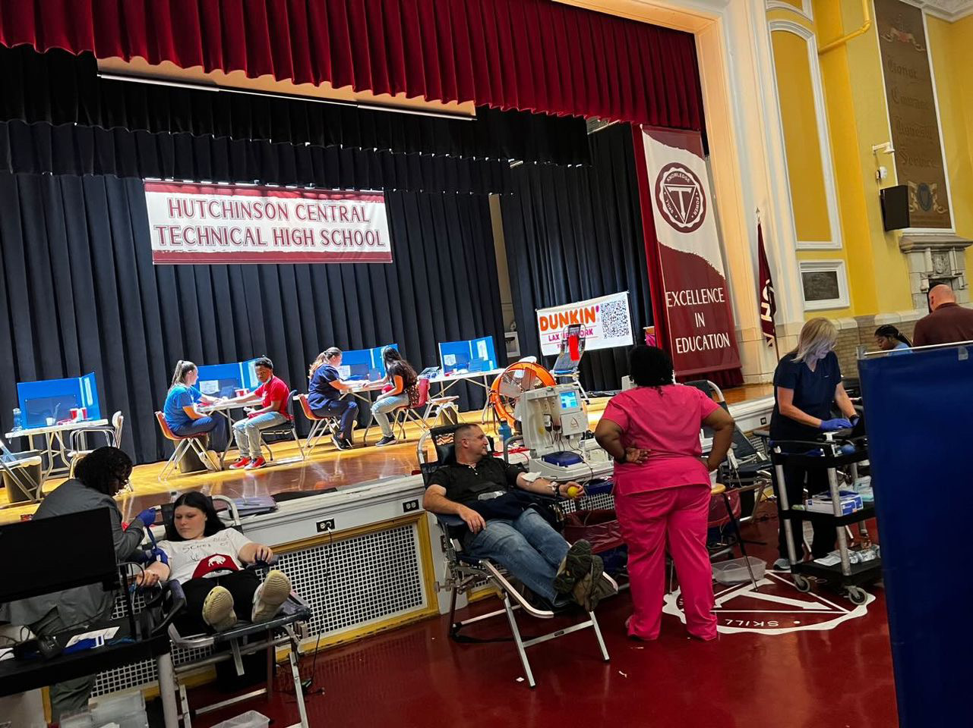
On September 16, The Connect Life Club hosted a blood drive. This month we had 53 donations! The project was led by Cadet Sergeant First Class Amy Mai with the assistance of many other cadets; the donations all proceeded successfully. We greatly appreciated all the support from our Tech Family and cadets who donated. Thank you to everyone. We hope to see you donate again!!

ENGINEERING DAY
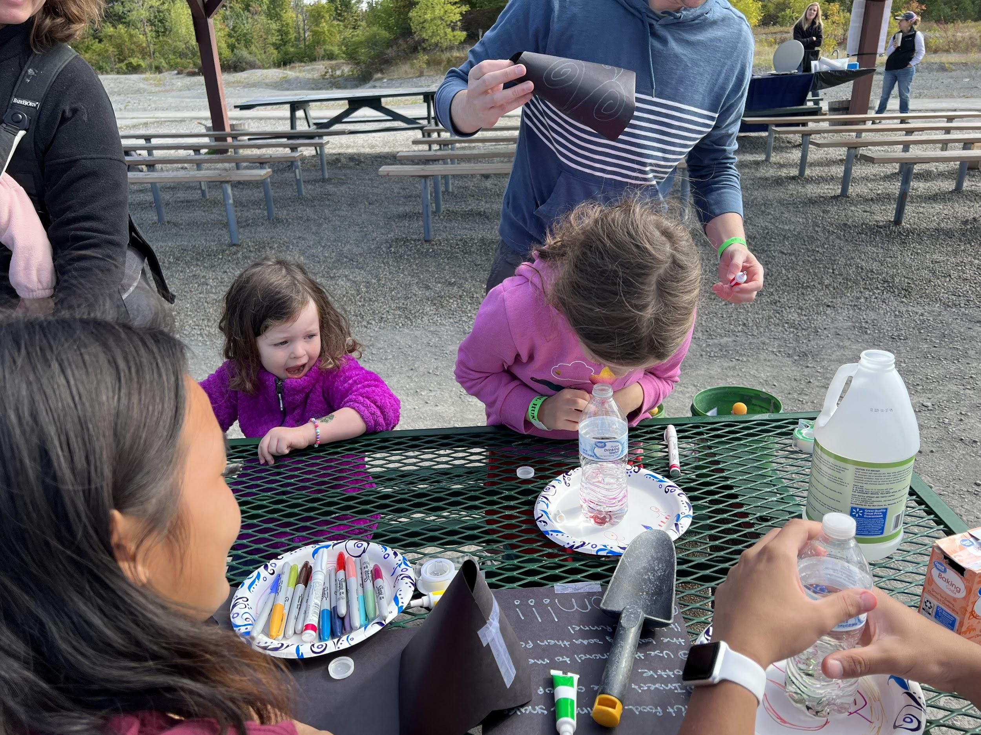
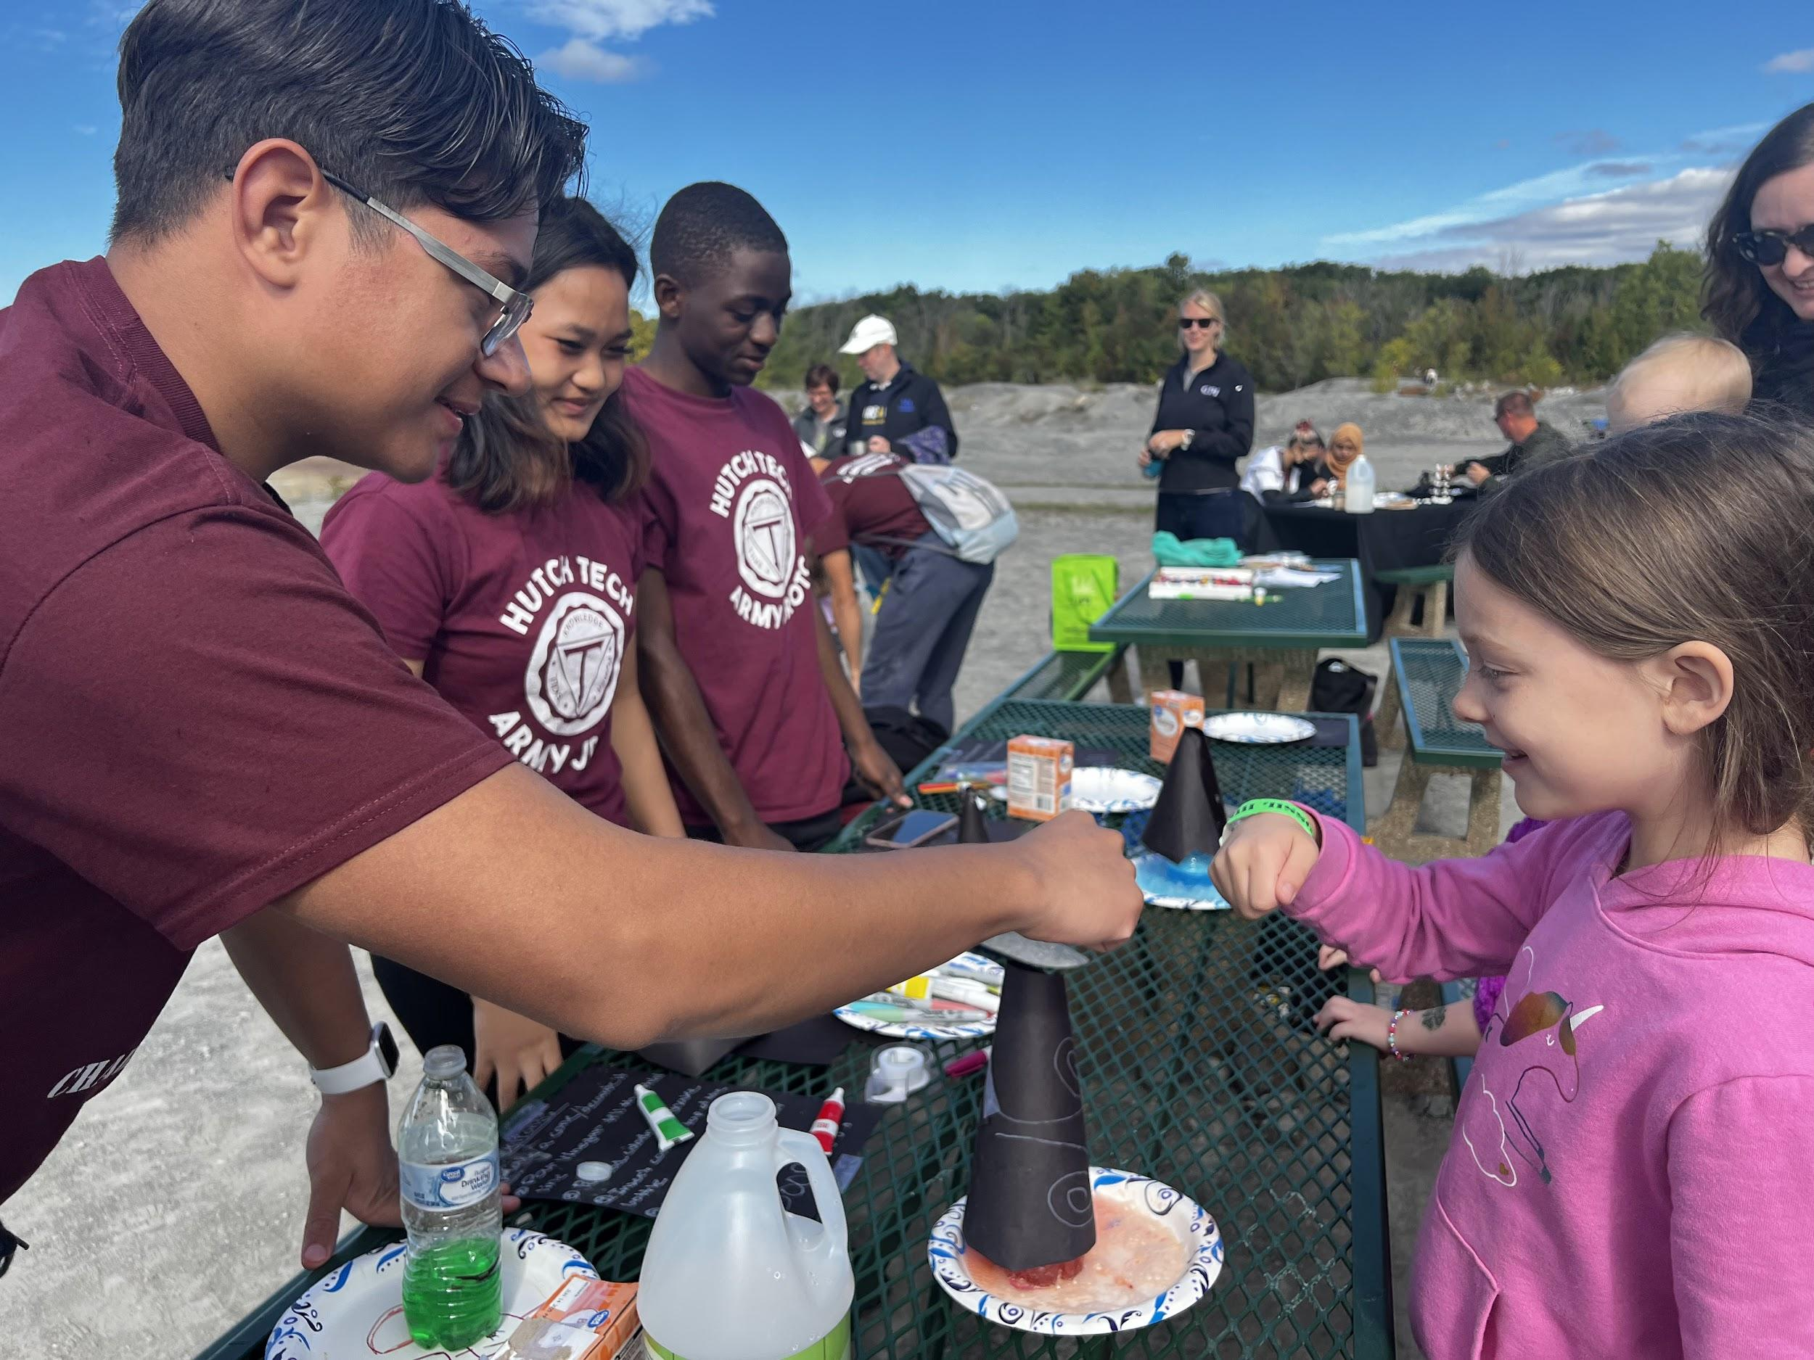
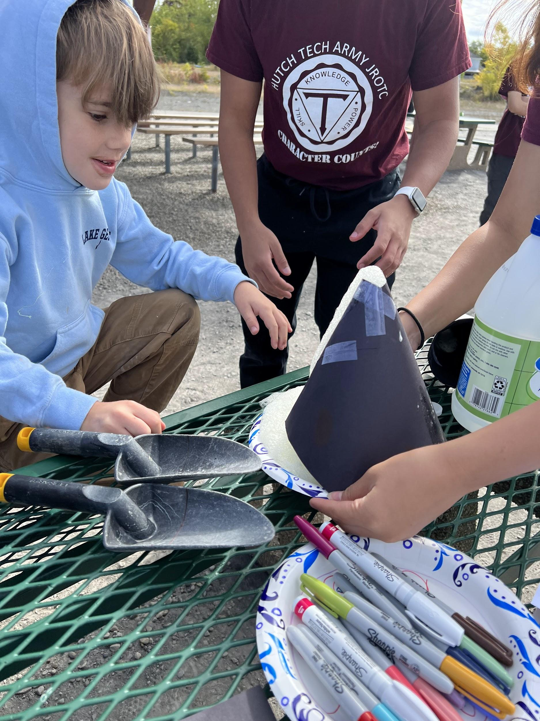
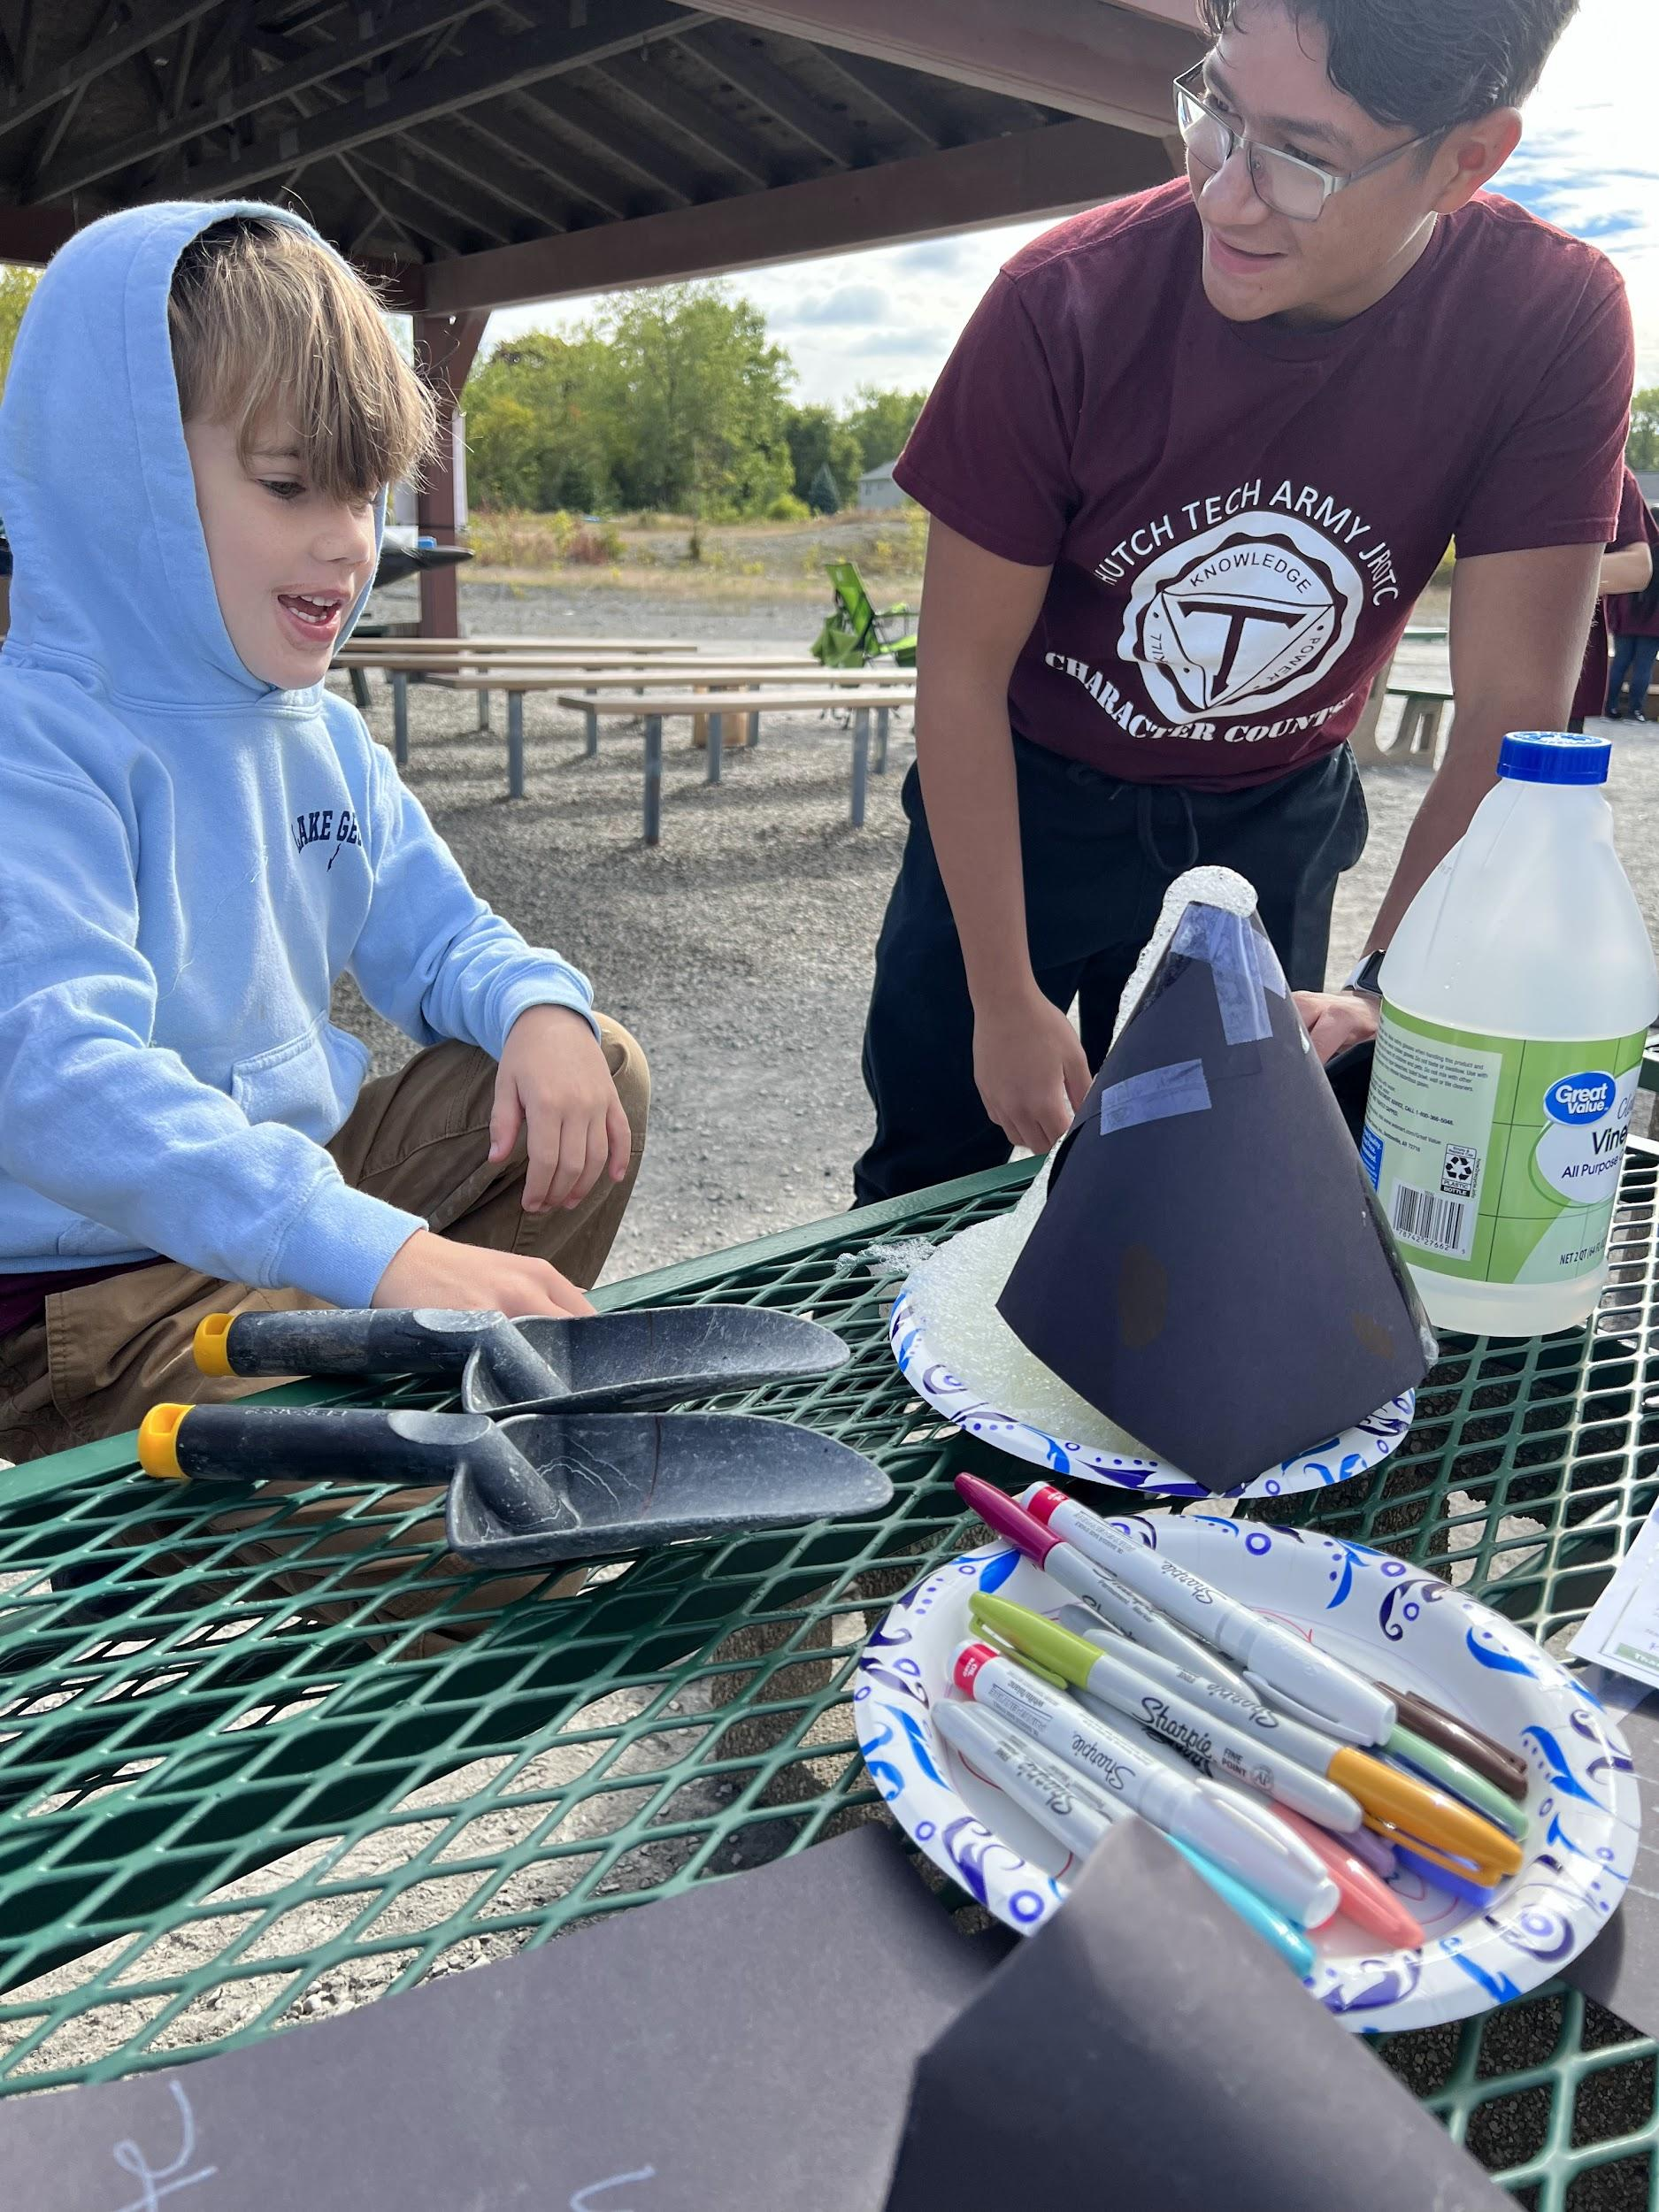
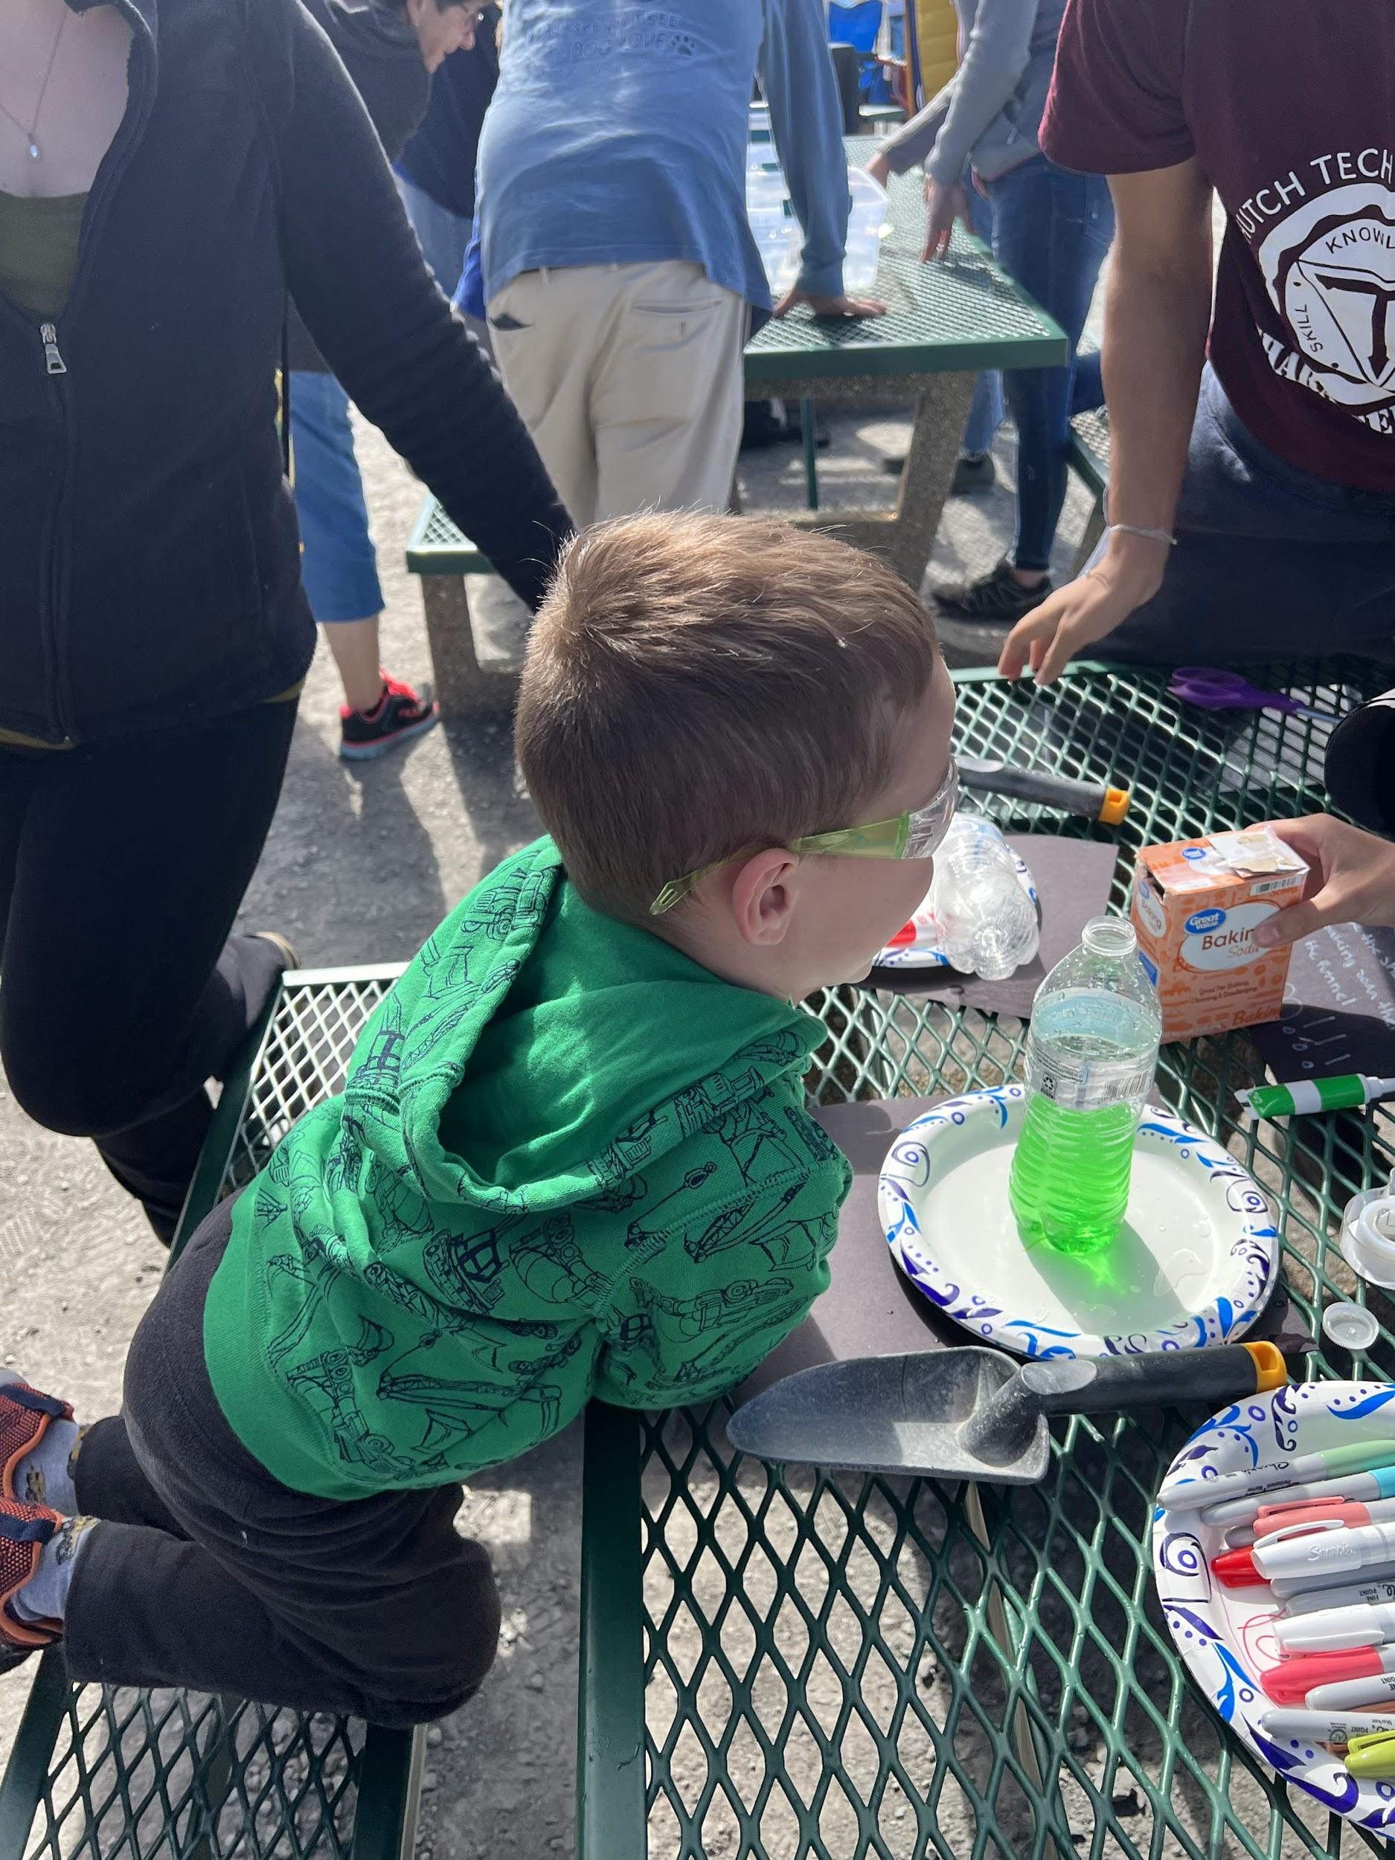
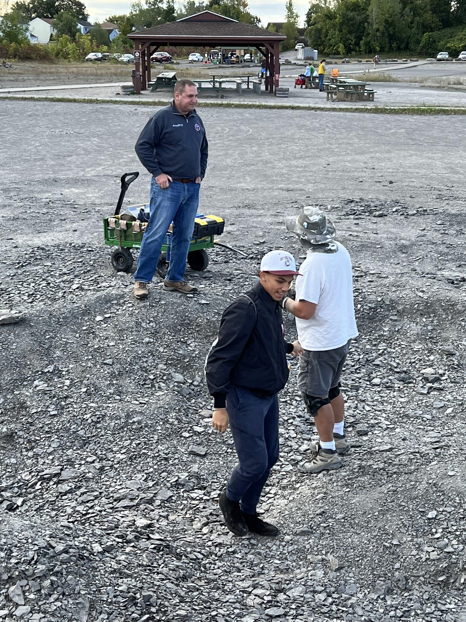
On September 24, 10 cadets (John, Mya, Dakeu, Lwenay, Yadriel, Tony, Afnan, Amy, Nuur, and Ismriti) volunteered to go to Penn Dixie Fossil Park. Before the event started the cadets went on a search for fossils. When the event started the cadets showed kids how to build a volcano and assisted with the admissions. Although many of the kids already knew how to build a volcano, they still enjoyed the process. The cadets also participated in some of the stations and won prizes. Seeing the kids' reactions was very heartwarming to the parents and to the cadets.

HIGHSCHOOL SHOWCASE
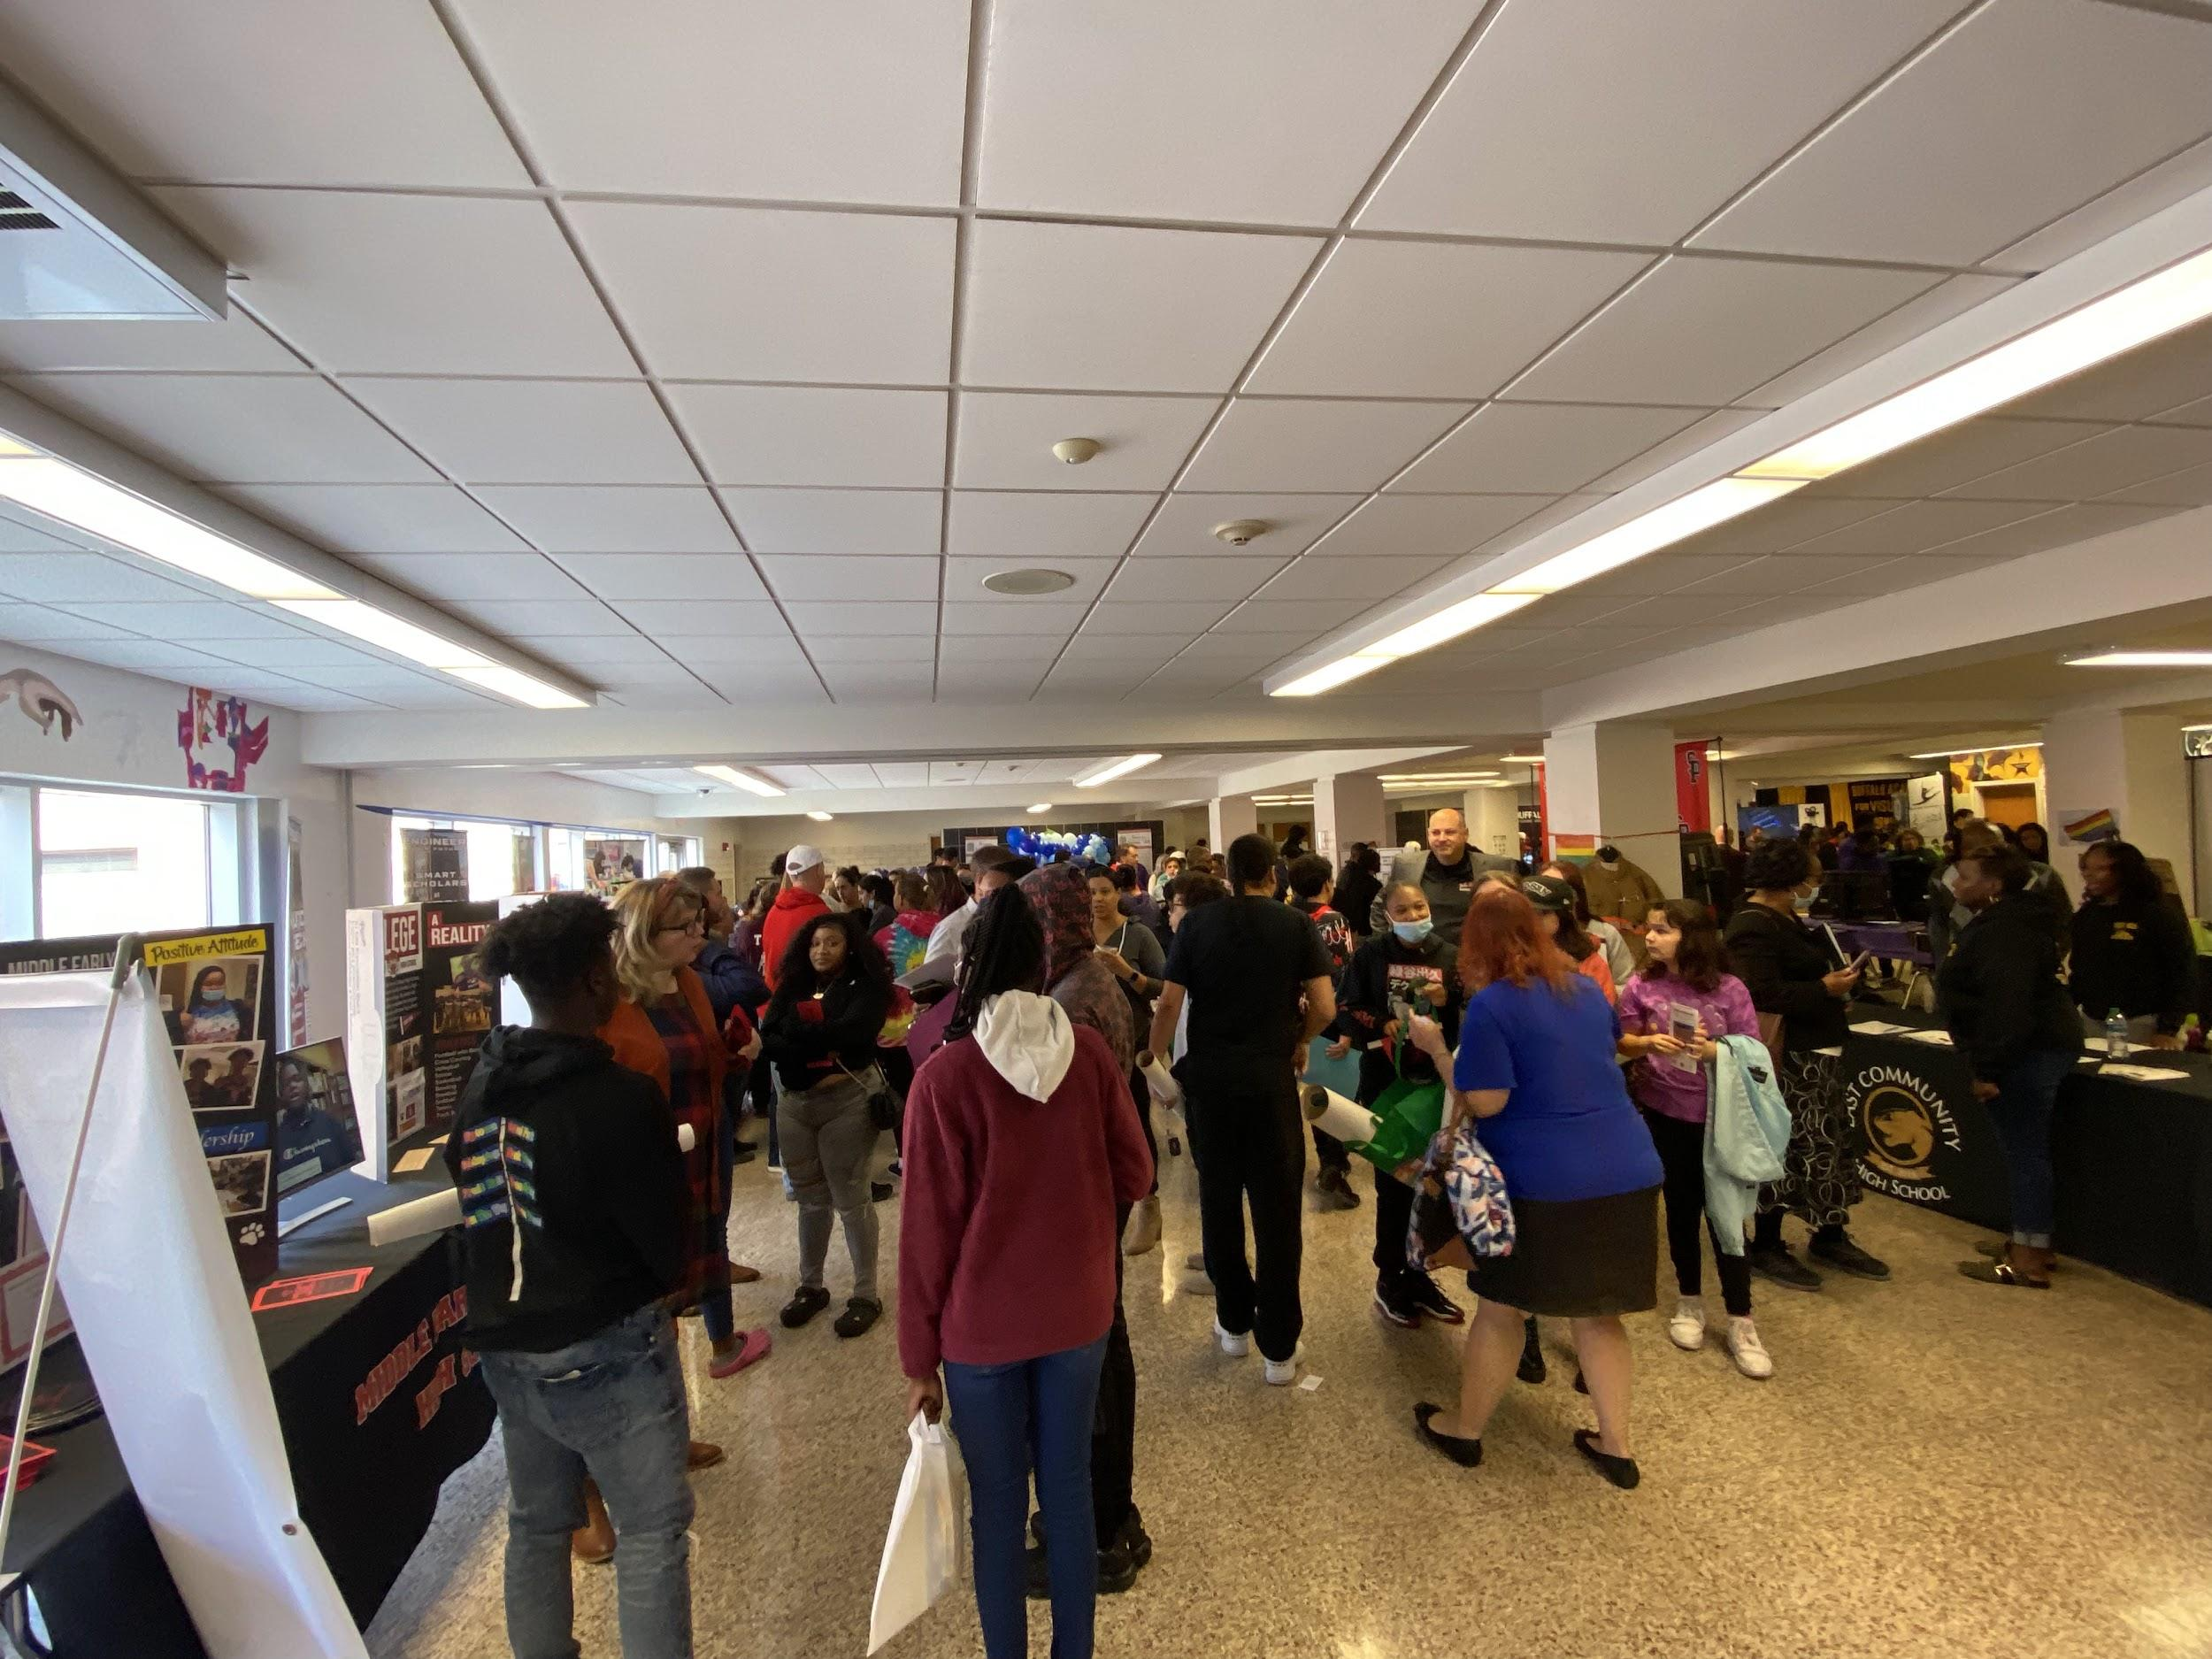
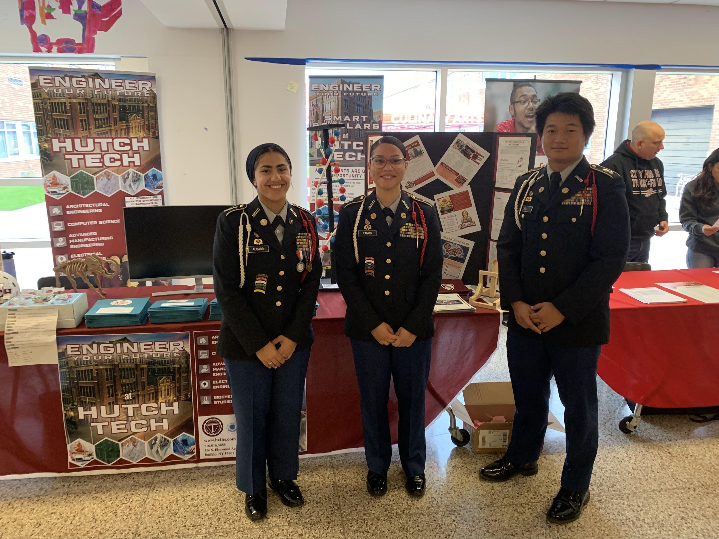
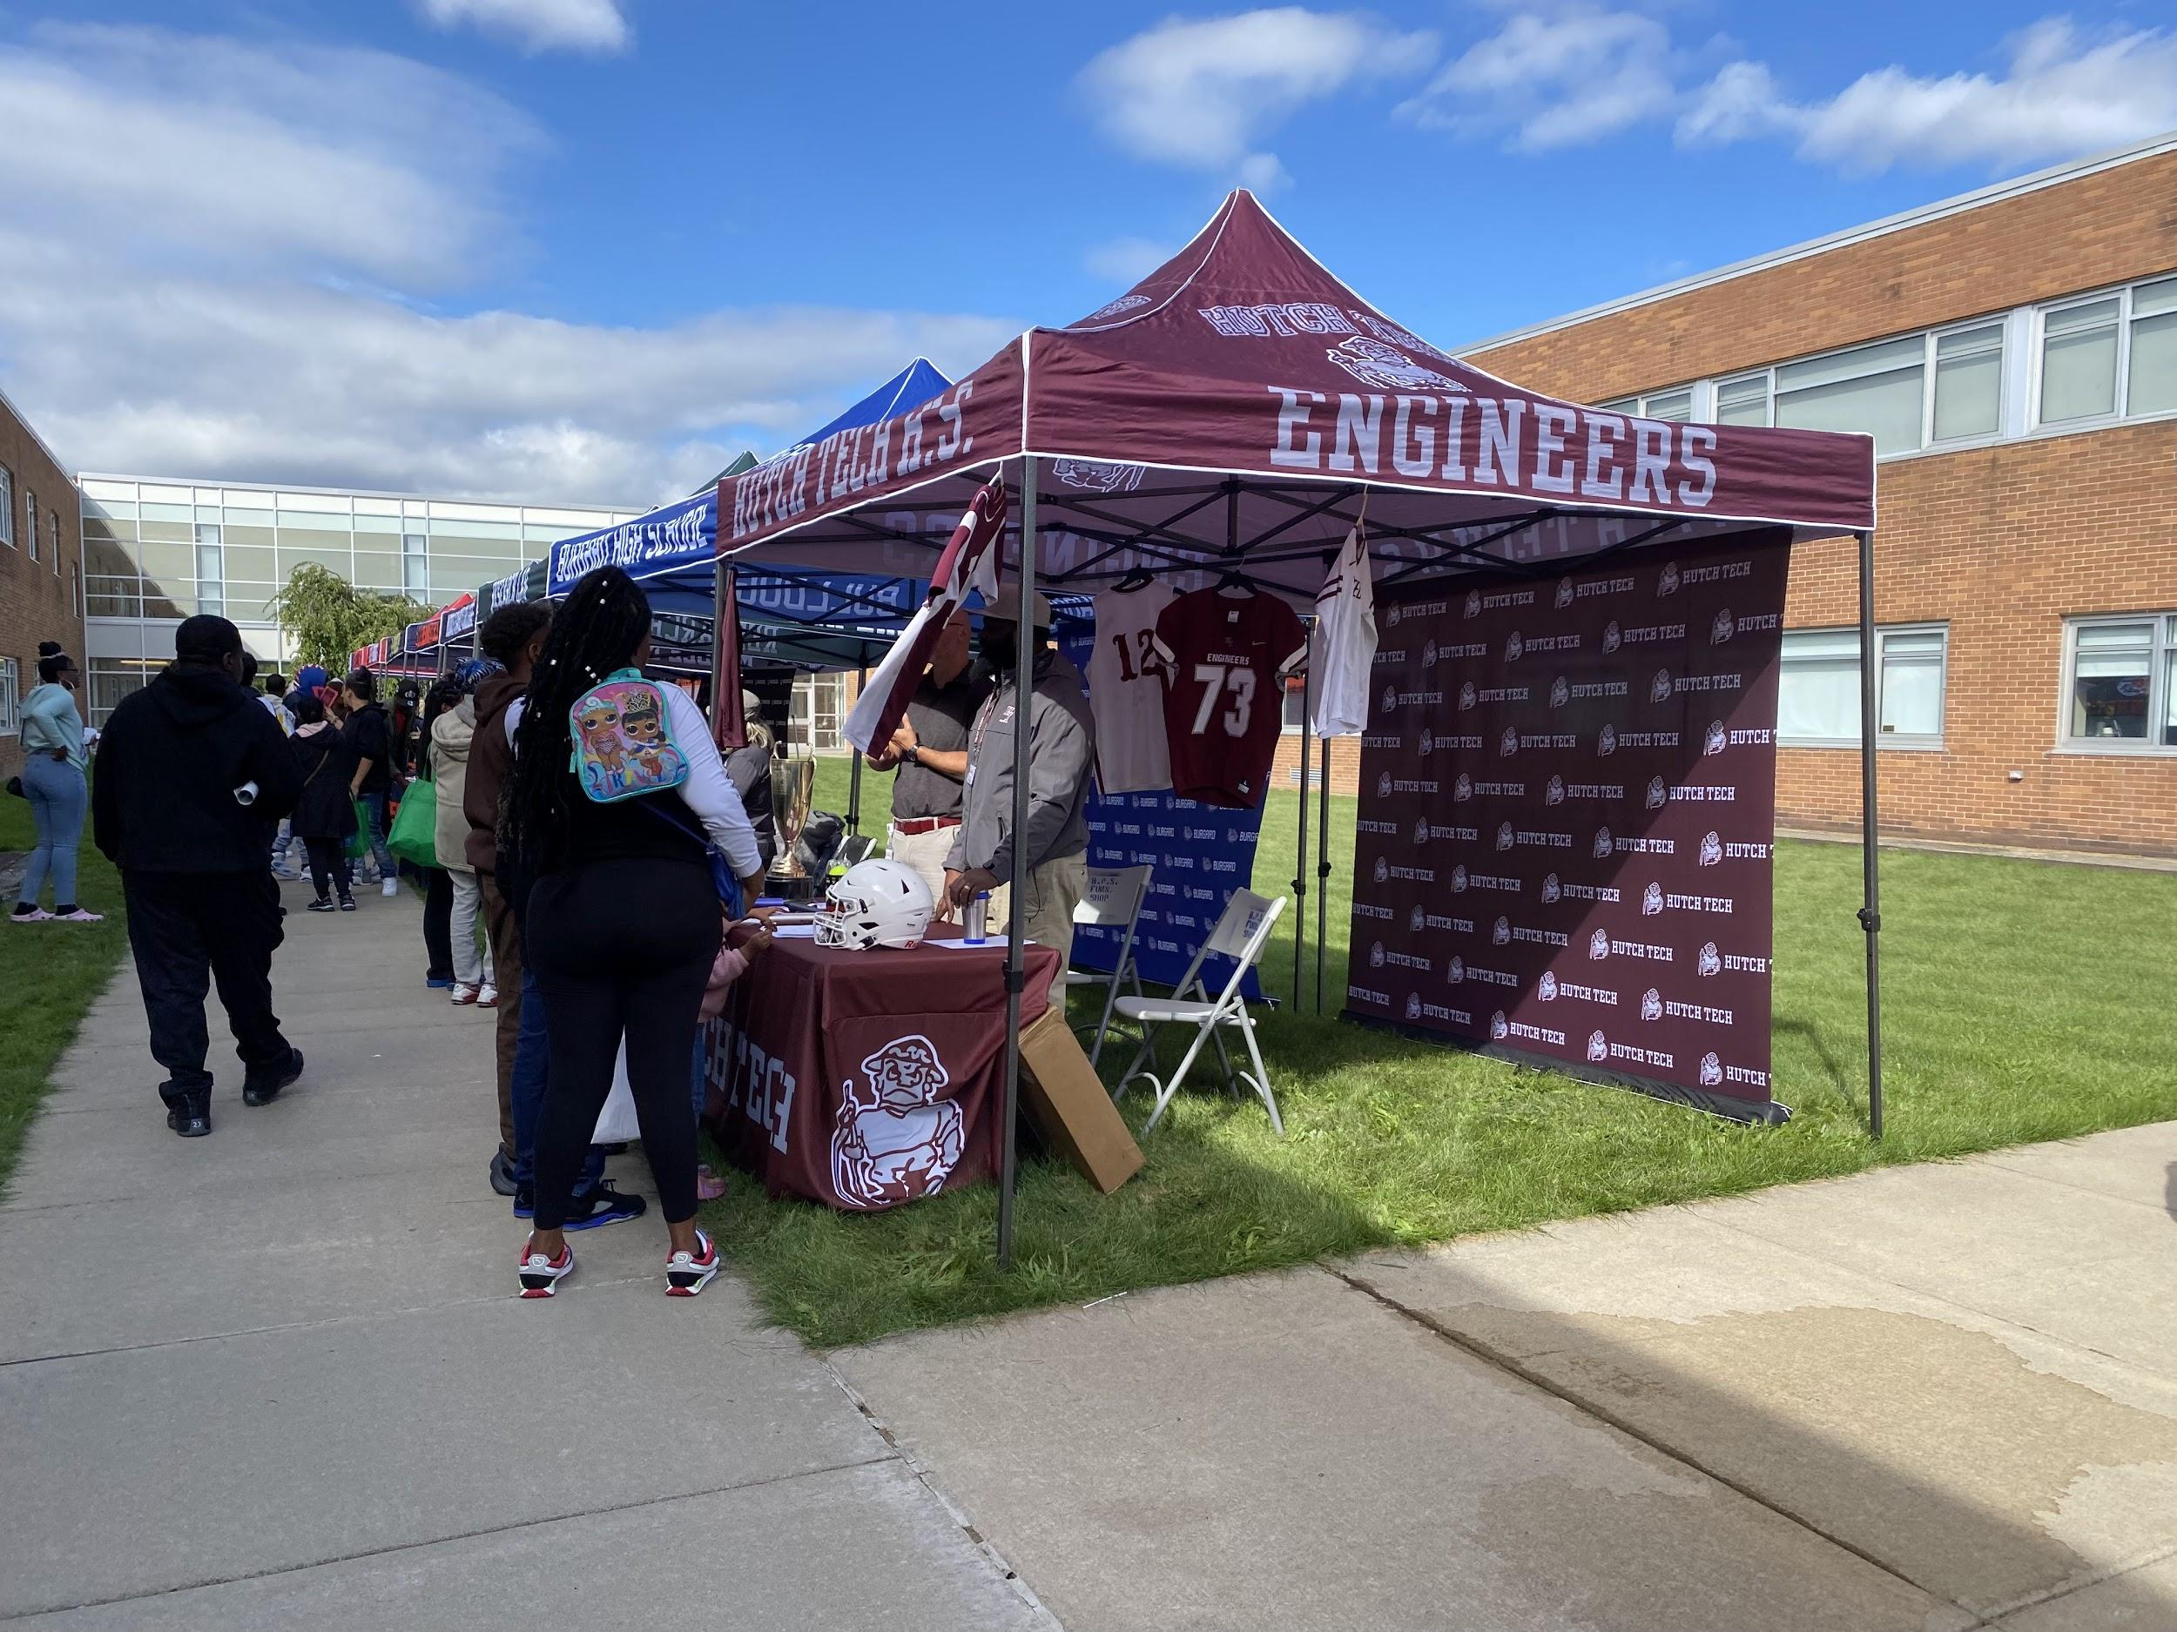
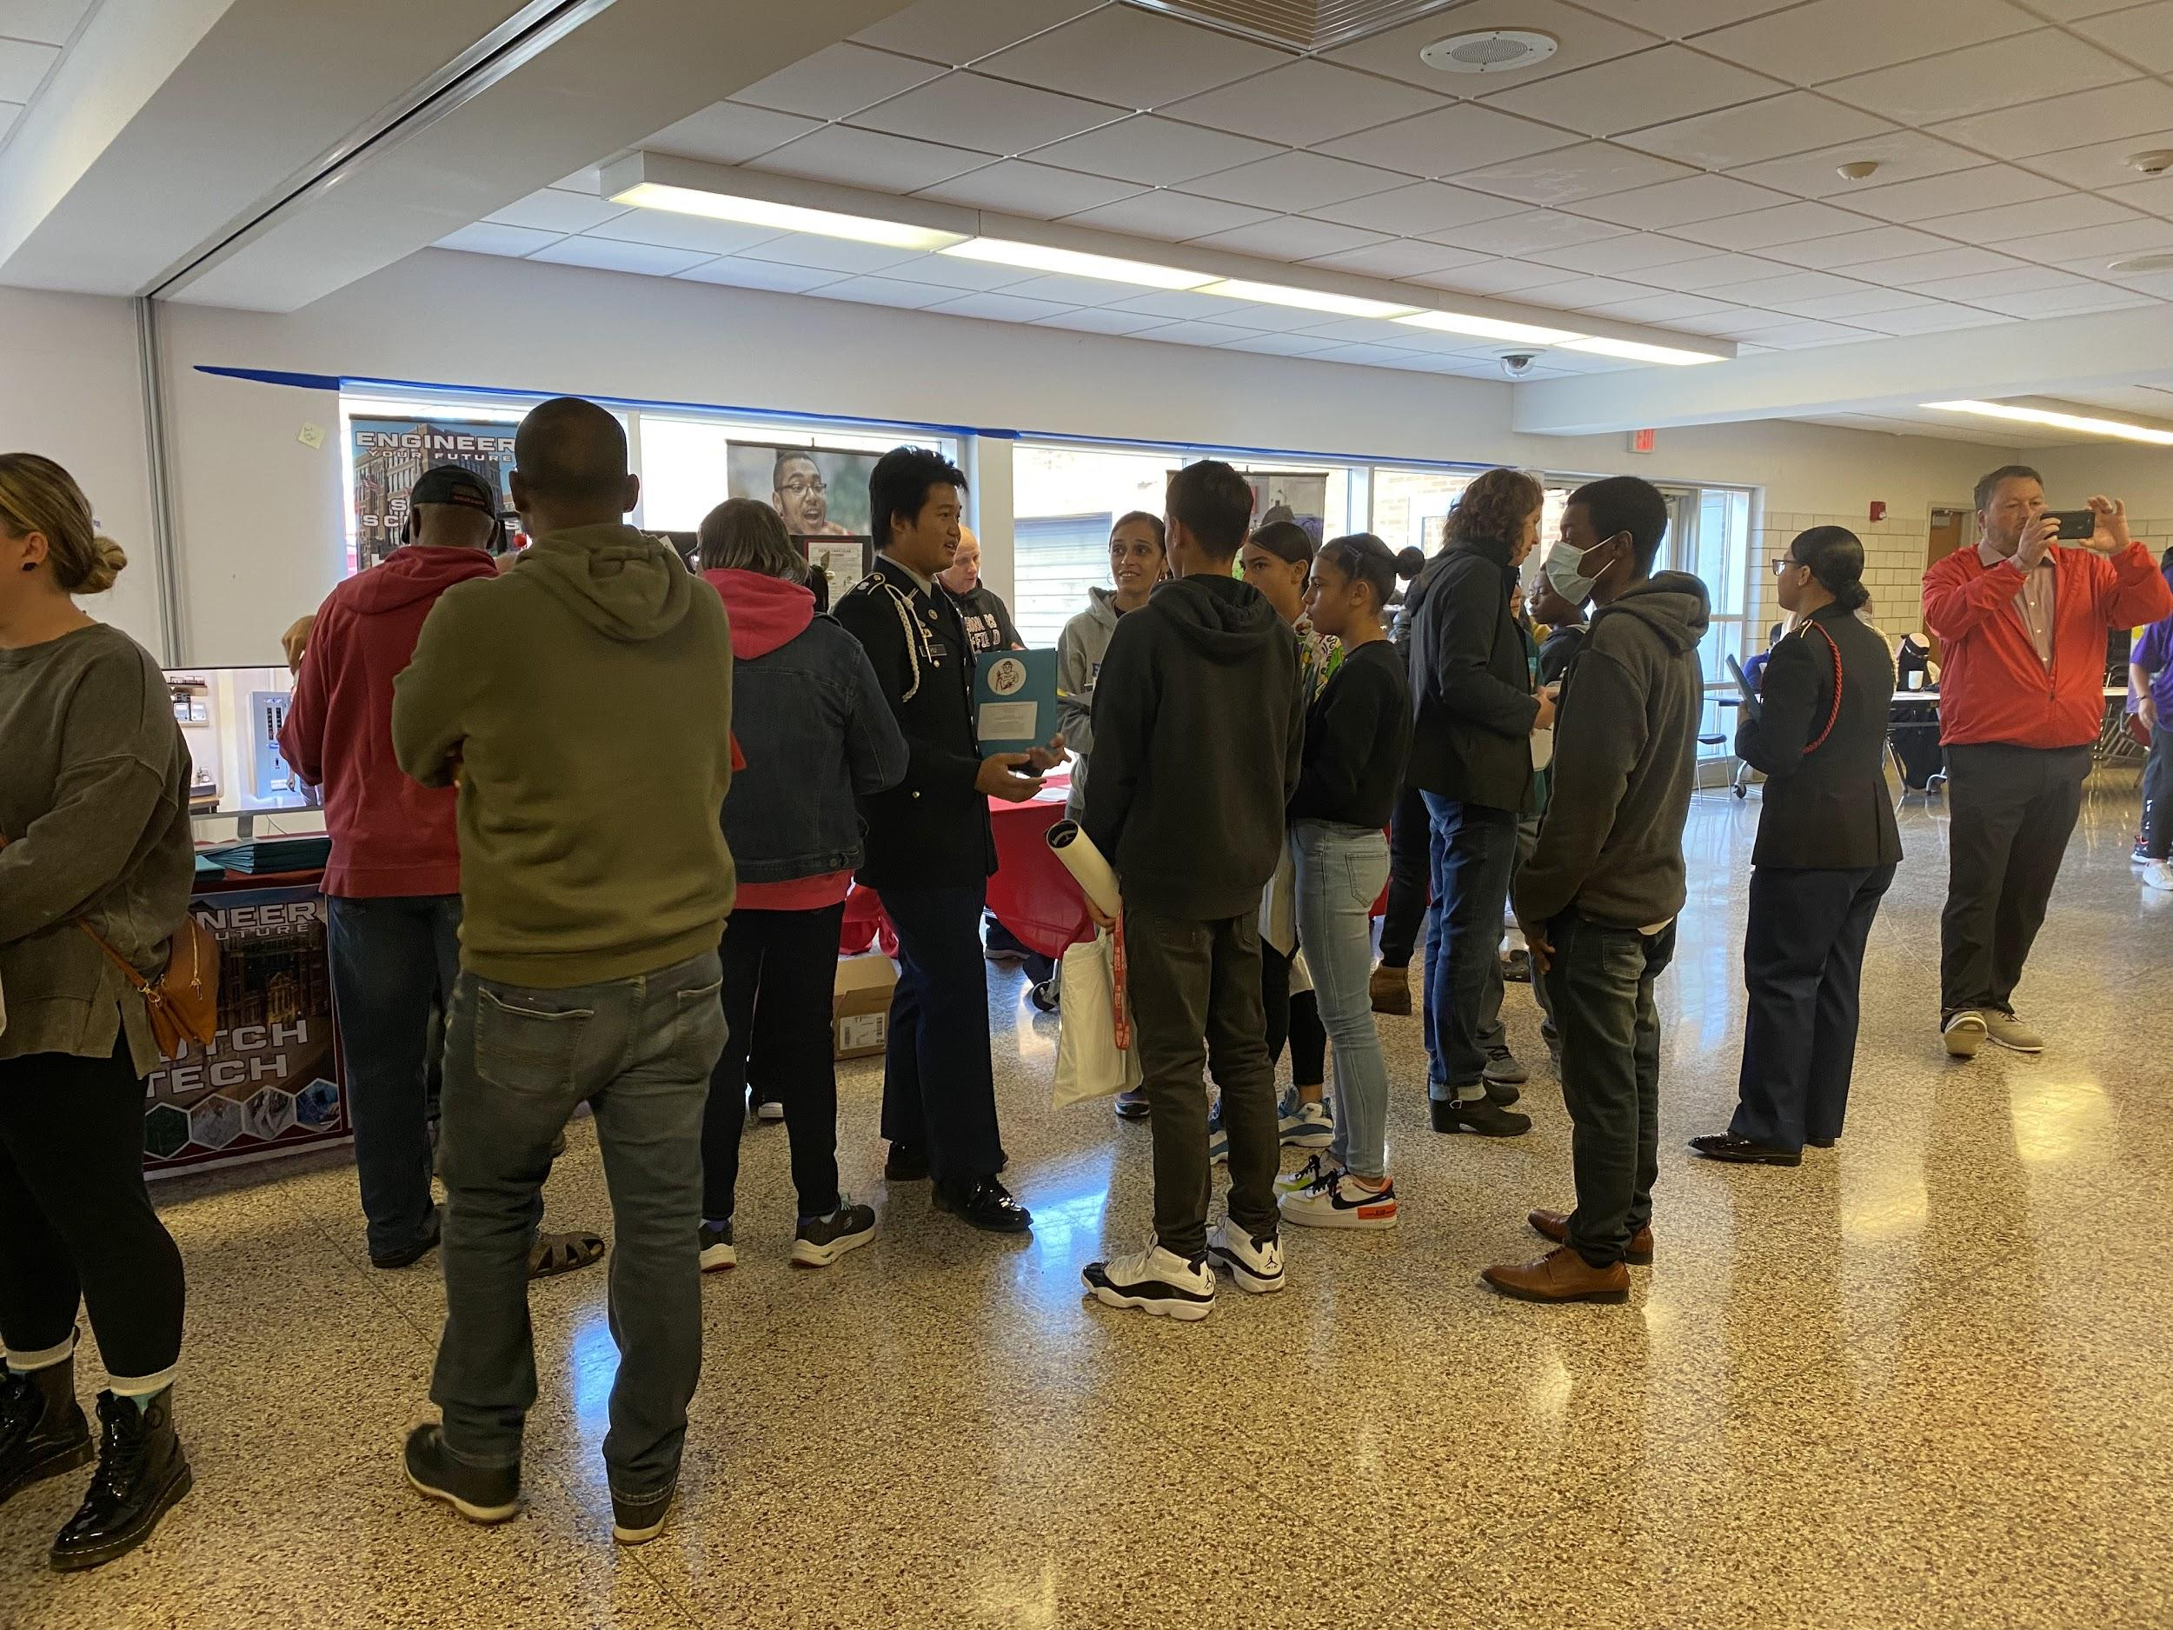
On September 24, cadets (Noor Albadri, Aniya Ramos, and Ku Ku) went to the high school showcase and represented our school and program. They attracted many people towards the stand and did their absolute best promoting. We are excited to see the freshmans that will join next year!

